Some Information and Links to Information about Self-harm/injury

(Online version: www.forms.ryandawes.co.uk/information/self-harm)

‘Self-harm elicits all kinds of responses in helping professionals...[and unfortunately] is often perceived negatively and managed punitively.’

Contents

Part A: Some information

1 ‘Self-harm/injury as a Response to Abuse/Prolonged and Repeated Abuse’ 4

2 ‘Self-harm/injury as a Way to Self-soothe’ 5

3 ‘Some Suggestions for Helping with Self-injury’ 6

4 ‘Some Information about Scars’ 7

5 ‘Some other Self-soothing Activities/Strategies’ 9

Part B: Some links to information

6 Book 10

A Bright Red Scream: Self-Mutilation and the Language of Pain 10

7 Website 10

Self injury Support 10

1. ‘Self-harm/injury as a Response to Abuse/Prolonged and Repeated Abuse’

‘...abuse engenders intense and uncontrollable internal affects such as rage, betrayal, fear, resignation, defeat and shame.’ (Christiane Sanderson, Introduction to Counselling Survivors of Interpersonal Trauma (London: Jessica Kingsley, 2010) 108.)

‘...very powerful reasons why a person...injure[s his/her] self... ... Many people who self injure feel unbearable distress, fear and tension.’ (‘Self Injury as a Coping Mechanism’, Ritual Abuse Network Scotland, 2013, <www.rans.org.uk/self-injury-as-a-coping-mechanism>.)

‘Self-harm...is a behaviour that can momentarily serve as self support when everything else feels impossible.’ (Andrew Reeves & Jules Howdin, ‘Considerations when working with clients who self-harm’, Talking Therapies: An Essential Anthology, 2nd edition (Leicestershire: BACP, 2008) 104.)

Expression of unallowed emotion

- ‘...fearful dependency and denial of rage [are ‘evoke[d]’] in the victim[s of abuse].’ (Sanderson, Survivors of Interpersonal Trauma, 33.)

  - ‘...express[ing] anger at the perpetrator...would jepordise survival.’ (Judith Herman, ‘Complex PTSD: A Syndrome in Survivors of Prolonged and Repeated Trauma’, Journal of Traumatic Stress 5:3 (1992): 382.)

- ‘...unexpressed anger and internalised rage...may lead to...behaviours [such as]...self-harm...’ (‘Complex Posttraumatic Stress Disorder’, TraumaDissociation, <www.traumadissociation.com/complexptsd.html>.)

- ‘...may feel angry, sad or anguished and...unable to shout, cry or speak...’ (‘Self Injury as a Coping Mechanism’, <www.rans.org.uk/self-injury-as-a-coping-mechanism>.)

As avoidance

- ‘...a means of numbing or... ...distracting away from...emotions...unable...to feel or deal with at that time.’ (‘Self Injury as a Coping Mechanism’, <www.rans.org.uk/self-injury-as-a-coping-mechanism>.)

As self-blame

- ‘Self-injury can be about self-blaming and turning anger and frustration inwards. ... ...often believes...really deserve[s] to be hurt.’ (‘Self Injury as a Coping Mechanism’, <www.rans.org.uk/self-injury-as-a-coping-mechanism>.)

2. ‘Self-harm/injury as a Way to Self-soothe’

‘The terror states induced in interpersonal trauma need to be quelled in order to manage and survive repeated abuse. To soothe and regulate these terror states survivors activate a range of survival strategies [‘...such as dissociation, avoidance...as well as self-medication through substance misuse and self-harm.’].’ (Christiane Sanderson, Introduction to Counselling Survivors of Interpersonal Trauma (London: Jessica Kingsley, 2010) 35.)

- ‘...self-harm...can be experienced as soothing and relieving…[allowing you ‘...to move into another more manageable state of being.’]’ (Andrew Reeves & Jules Howdin, ‘Considerations when working with clients who self-harm’, Talking Therapies: An Essential Anthology, 2nd edition (Leicestershire: BACP, 2008) 104.)

  - ‘Injury can...cause a release of endorphins – the body’s natural painkillers, thus providing a ‘natural high’…’ (Reeves & Howdin, ‘Clients who self-harm’, 104.)

  - ‘This temporary sense of well-being can come in stark relief to the moment by moment sense of distress and despair.’ (Reeves & Howdin, ‘Clients who self-harm’, 104.)

- ‘Hurting...can act as a kind of safety valve and bring a sense of great relief...’ (‘Self Injury as a Coping Mechanism’, Ritual Abuse Network Scotland, 2013 <www.rans.org.uk/self-injury-as-a-coping-mechanism>.)

3. ‘Some Suggestions for Helping with Self-injury’
(Adapted from ‘Helping with Self Injury’, Ritual Abuse Network Scotland, 2013 <www.rans.org.uk/helping-with-self-injury>.)

- Sterilise blades or whatever else is used
- Keep antiseptic wipes handy
- Clean injuries
  - For burns run cold water over them until they cool
  - For cuts clean using antiseptic wipes and cover with a clean dressing

- If a cut is deep and will not stop bleeding apply pressure until it stops

Medical attention will usually be needed if
- bleeding continues/does not stop
- a cut is deep
- a burns is large or deep
- an infection gets into the wound

You have the right to medical attention if needed/sought.

Also:
- staff can be asked to explain clearly all treatment being provided
- you have the right to refuse to have a student observing or treating you
- treatment should not be dependent on agreeing to psychiatric intervention
- you have the right to pain relief

4. ‘Some Information about Scars’
(From ‘Information about scars’, Self injury Support, 2017 <www.selfinjurysupport.org.uk/docfiles/Information-about-scars.pdf>.)

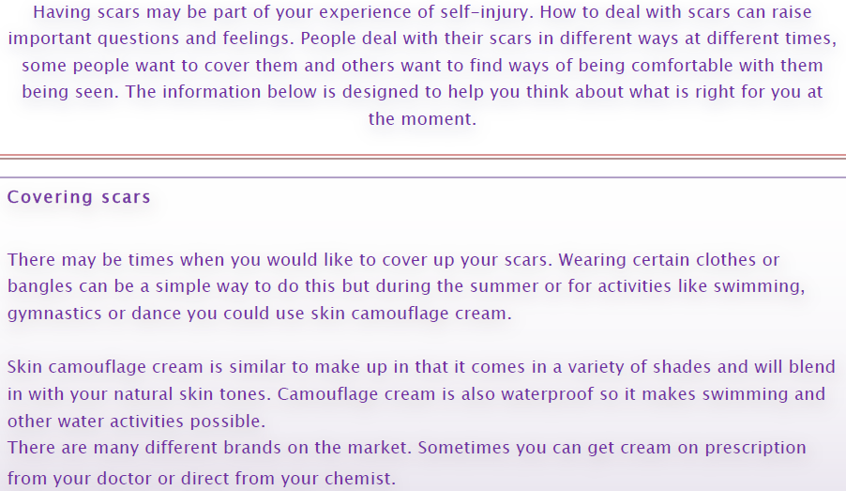

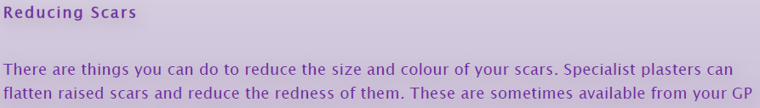

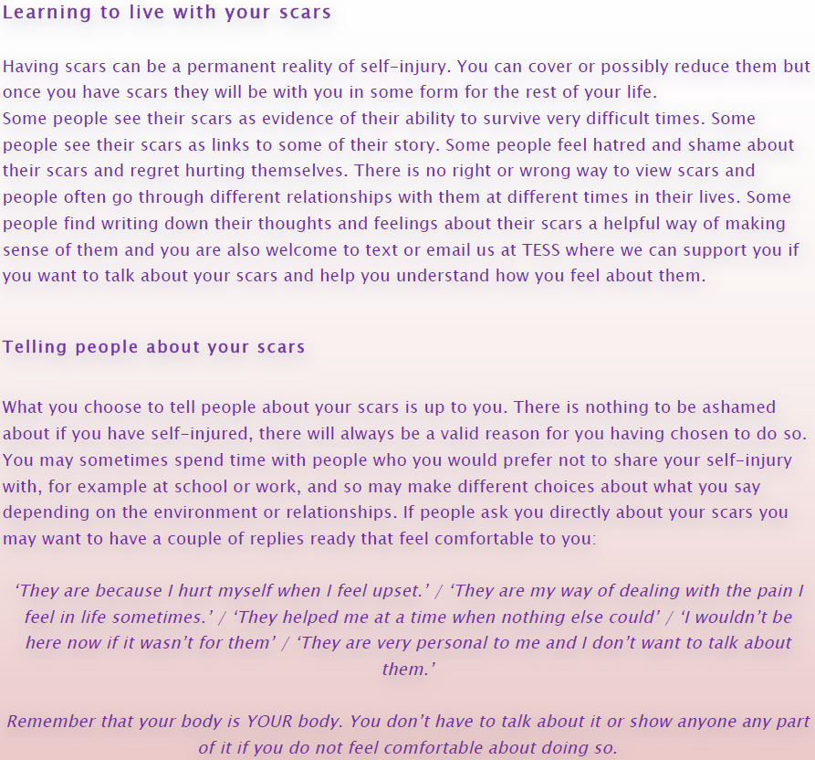

5. ‘Some other Self-soothing Activities/Strategies’
(Adapted from Survivor to Thriver: Manual and Workbook for Adult Survivors of Child Abuse Who Want to Move-on with Life (California: The Morris Center for Healing from Child Abuse, 1999) 31-32.)

Self-soothing can/may involve
- touch that is warm and comforting
- words that are reassuring, empathic and hopeful
- activities that are physically, intellectually or sensorially nourishing
- daily practices that are spiritually uplifting and inspiring

Some examples/possible ways to soothe yourself:
- Taking a walk/exercise
- Taking a warm bath
- Reading a/your favourite book
- Writing in your journal
- Doing a spiritual practices
- Practicing meditation, guided imagery or deep relaxation

6. Book

A Bright Red Scream: Self-Mutilation and the Language of Pain by Marilee Strong (New York: Penguin, 1998; London: Virago, 2000) ISBN: 0-14028-053-7 / 1-86049-754-3

‘...shatters the stereotypes and dispels the myths surrounding...self-mutilation...’

Available at www.abebooks.co.uk and www.amazon.co.uk (approximately: £11 (new), £.2.50(used copy))

7. Website

Self injury Support

‘We particularly help girls and women who harm themselves...’

www.selfinjurysupport.org.uk/resource-hub

Andrew Reeves & Jules Howdin, ‘Considerations when working with clients who self-harm’, Talking Therapies: An Essential Anthology, 2nd edition (Leicestershire: BACP, 2008) 104.

